**Problem Statement**

Time series forecasting consists in a research area designed to solve various problems, mainly in the financial area. It is noteworthy that this area typically uses tools that assist in planning and making decisions to minimize investment risks. This objective is obvious when one wants to analyze financial markets and, for this reason, it is necessary to assure a good accuracy in forecasting tasks. [3] Machine learning (ML) is coming into its own that can play a key in a wide range of critical applications. In machine learning, support vector machines (SVMs) have many advanced features that are reflected in their good generalization capacity and fast computation. They are also not very sensitive to assumptions about error terms and they can tolerate noise and chaotic components. Notably, SVMs are increasingly used in materials science, the design of engineering systems and financial risk prediction. [1] Also, most methods that are in use are only applicable to a small portion of stock markets and usually such models do not generalize well to all stocks. Additionally, existing libraries are highly efficient in obtaining the optimal hyper parameters to be used in LSSVM and other algorithms.

Since time series data can be formulated by regression analysis, LSSVR is very efficient when applied to the issue at hand. However, the efficacy of LSSVR strongly depends on its tuning hyperparameters, which are the regularization parameter and the kernel function. Inappropriate settings of these parameters may lead to significantly poor performance of the model. Therefore, the evaluation of such hyperparameters is a realworld optimization problem. [4] Because the performance of SVR-based models strongly depends on the setting of its hyperparameters, they used to be set in advance based on the experience of practitioners, by trial-and-error, or using a grid search algorithm. Thus, finding the optimal values of regularization and kernel function parameters for SVR-based models is an important and time-consuming step. Therefore, a means of automatically finding the hyperparameters of SVR, while ensuring its generalization performance, is required.

**Related Works**

**Proposed System Architecture and Dataset**

Decision to buy or sell a stock is very complicated since many factors can affect stock price. This work presents a novel approach, based on least squares support vector regression (LSSVR), to constructing a stock price forecasting expert system, with the aim of improving forecasting accuracy. The intelligent time series prediction system that uses sliding-window metaheuristic optimization is a graphical user interface that can be run as a stand-alone application. The system makes the prediction of stock market values simpler, involving fewer computations, than that using the other method that was mentioned above [1]. Additionally, the proposed system automatically fetches the latest stock data for any given company and date range

Historically prices were taken from Yahoo! Finance, a publicly accessible website, as they were by Six years (October 5, 2011 to May 31, 2017) of daily data on five company stocks were downloaded from Yahoo! Finance.

The data were closing stock prices.

The features of the dataset include :

Date

Open High

Low Close Volume

Divident Split

Adj_Open Adj_High Adj_Low

Adj_Close Adj_Volume

**Architecture Diagram**

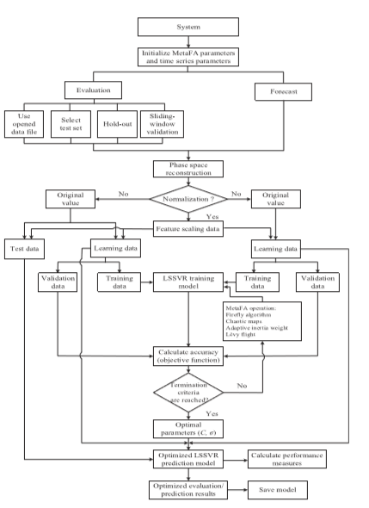

**Detailed Module design**

**Implementation Details**

**Metrics for Evaluation**

**References**

1. C. M. Anish and B. ​Majhi Hybrid nonlinear adaptive scheme for stock market prediction using feedback FLANN and factor analysis ​ J. Korean Statist. Soc. 2016.

2. R. Dash and P. Dash Efficient stock price prediction using a self evolving recurrent neuro-fuzzy inference system optimized through a modified differential harmony search technique Expert Syst ​ .2016.

3. Bhattacharya, A. Konar, andP.Das,​Secondaryfactorinducedstockindextime-series prediction using self-adaptive interval type-2 fuzzy sets ​ ,2016.

4. J.-S. Chou, K.-H. Yang, J.P.Pampang,andA.-D.Pham,​Evolutionarymetaheuristic intelligence to simulate tensile loads in reinforcement for geosynthetic-reinforced soil structures, Comput. Geotechnics ​ , 2015.

5. J.-S. Chou and A.-D. Pham, ​Smart artificial firefly colony algorithm based support vector regression for enhanced forecasting in civil engineering ​ , Comput.-Aided Civil Infrastructure Eng, 2015.

6. D. Saini, A. Saxena, and R. C. Bansal, ​Electricity price forecasting by linear regression and SVM, ​ in Proc. Int. Conf. Recent Adv. Innov. Eng, 2016.

7. J. Wang, R. Hou, C. Wang,andL.Shen,​Improvedv-supportvectorregressionmodel based on variable selection and brain storm optimization for stock price forecasting, Appl. Soft Comput, 2016.

8. A. Jindal, A. Dua, K. Kaur, M. Singh, N. Kumar, and S. Mishra,​Decisiontreeand SVM-based data analytics for theft detection in smart grid ​ , IEEE Trans. Ind. Informat,2016.